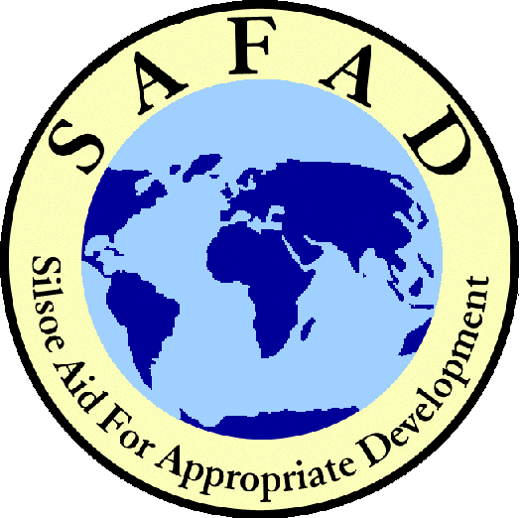
SAMSON

The twice yearly newsletter of SAFAD  E-mail: safad@cranfield.ac.uk  Website: http://www/silsoe.cranfield.ac.uk/safad | Page 1:  Page 2:  Page 3:  Page 4: | Message from the SAFAD President  Our AGM, Fundraising and Financial Update  Update from our current projects  Our new volunteers and vote of thanks

Welcome once again to SAMSON, the SAFAD Members’ Source of News! It is proving to be a very good year for our 33-year old organisation – but more particularly for the people in the communities with whom we are working.

We have attempted to grow: through additional members, spreading our activities across Silsoe’s expanding range of disciplines, generating more funds and developing new projects. I am really happy to be able to report that we are achieving all of these goals - thanks to you. Because we have raised our largest ever sum of funds, we could send 16 Silsoe graduate volunteers overseas this autumn - our largest ever contingent - to existing and new projects, with a small boost to our current bank balance!!!

The new projects are beginning to take shape (see p4); we will be working with Ethiopian NGO Sunarma on a project at Wof-Wosher some 150km east of Addis Ababa, helping the community there to reintroduce appropriate agricultural and other revenue generating practices for their benefit and to help to reverse the poverty-induced cycle of destruction of the area’s precious native forest. We have a student in Zambia working to set up a medical diagnostics project there in one of the urgent arenas of HIV/AIDS or malaria. We are also looking at a further ‘medi-diag’ project in South Africa. Other future ‘possibles’ include Yunnan Province in China and Kenya. In the meantime, our existing projects proceed apace; for details of these and the great work that has been carried out this year please see p3.

Growing project activity means we leave a great legacy for the next committee on the one hand but an increased expenditure and energy requirement on the other (see Back Page – Fundraising Note). Heartfelt thanks to you all for your continued support; please help to keep SAFAD’s invaluable work going and growing.

Peter Ryan
President 2002-3

Thank you to you all: Denis Buxton Trust, The Norben Charity, G. Eggleston, C. Neame, J. Aked, E. Pirie, R. Thornton, J. Cain, P. Woodland, H.B. Allen Charitable Trust, K. Danert, Mr Grogan & Mrs A. Keegan, C. Allerton, Alfred Haines Charitable Trust, Beatrice Laing Charitable Trust, R. Carter, J. Napper, Chaps Inc., Steer Davies Gleave, M. Smethurst, M. Jeeves, R. Radley, S. Neo, J. Neville, TWOAT, B. Williams, G. Lovelace and the Rotary Clubs of Hitchin Priory and Mimram Valley

The SAFAD annual seminar was held on Wednesday 7th May and this year focused on SAFAD’s project work. Many attendees commented on the high quality of presentations and how they found them challenging and informative. The meeting went smoothly thanks to our superb chairperson, SAFAD patron Sir Crispin Tickell. Sir Crispin also gave the closing address on sustainable development, where we are now and where we need to go to achieve the millennium development goals. Piers Langdon gave a talk on SUNARMA a new project that SAFAD is supporting this year. SUNARMA works with communities around Wof-Wosher forest. The area is heavily degraded due to food insecurity and population pressure. This high forest has great importance not only to the local people but to the entire nation and countries lying beyond on the watershed of the Blue Nile and Awash Rivers. Andy Trevett a lecturer at Silsoe, who volunteered with SAFAD in Guatemala when he was a student shared his SAFAD experiences, and Nick Evans a current Agro-forestry volunteer in Malawi spoke about his achievements there and his hopes for the future of the project.
Philippa Ross
Vice President

SAFAD has held a number of fundraising events this year. January and February were busy months with a 1970’s style disco, complete with fancy dress, and a Bring and Buy sale. Also in January we were privileged to have the director of WaterAid, Ravi Narayanan, as the guest speaker at SAFAD’s inaugural annual lecture, held in honour of our former Advisory Panel, Derek Sutton. Ticket sales for this event raised around £250 for SAFAD. February saw another Bring and Buy sale as the first turned out to be so successful. On the 7th February we held a traditional Scottish Burns night in Silsoe village hall. The poetry readings, Scottish dancing and band with piper proved very popular and everyone seemed to enjoy their evening. However the haggis was a mixed success, with many of the unsuspecting international students trying it for the first time. We also held a raffle with prizes kindly donated by many committee members and students. Prizes were also obtained from the Odeon cinema in Luton, who generously donated six free cinema passes, and Tesco in Flitwick who gave us a £10 voucher. Cranfield University’s annual International day was held on the 22nd February this year and a proportion of ticket sales were donated to SAFAD. As our contribution to the events we sang a song from the musical Grease!

To sum up the first few months of 2003 have seen a number of successful, entertaining and educational events that have brought in a lot of money for SAFAD and raised our profile around the University and Silsoe village.
Rachel Roberts
Fundraiser

The 2002-2003 SAFAD accounts have just been completed and it is clear that is has been a very successful year for SAFAD. £31,600 has been raised which is £9,000 up on last year’s total. We have also seen a 100% increase in Gift Aid revenue. All funds raised are spent directly on sending the students of Silsoe to help relieve poverty in the less developed world. We have also doubled the amount of money raised through

SAFAD events (£4,000) both on campus and in the village, which not only means we can send another volunteer abroad, but has also helped to increase the profile of SAFAD and encourages further involvement in SAFAD. Please keep the donations coming in so that we can make 2003-2004 even more prosperous for SAFAD. And remember to Gift Aid your donation! Davinia Gornall Treasurer

Both volunteers returned home after completing their project objective in the six months. The design and research was completed on the database. The system contains all of the previous work carried out by AIRES, including interactive maps of farm and nurseries. It also contains an analysis of AIRES’ work from responses of the communities. A significant start has been made into investigating possible links and utilisation of Fairtrade organisations for the communities. Laura is back in Spain but is continuing to work in her own time on finishing some community participation project analysis reports.

Malawi 2002 – 2003: Justin and Nick had a very successful 6 months, which has resulted in Nick extending his stand for a further 6 months. Nick spent his time setting up experimental plots to demonstrate soil and crop benefits of agro forestry techniques and has been exploring the future of macadamia carrying out yield investigations for the next 15 yrs. Justin focused on the training and development for project activities as well as designing PRA (Participatory Rural Appraisal) tools to be used in June. Justin also concentrated on looking at risks the project faces in order to plan and manage the project better, and accounting for worst-case scenarios. Together Justin and Nick have produced a 3yr plan for expansion into the neighbouring district Mwanza bringing a further 250-300 farmers into project activities.

They have produced a supplementary budget and proposal for the establishment of the new office site for COMPASS (US AID) and Malawi Environment Endowment Trust (MEET) (Malawian NGO’s). The new office will be a teaching area and will be used to promote health (HIV/TB), education (adult literacy), democracy etc.

The work improving the catchment was completed. Dave and current volunteers said that “It was a great relief to see the taps flowing again” meaning that all their hard efforts were not in vain. The quantity of water is more than enough for the village, so their dry season problems should be over. Another success but not the last one…..…

The volunteers worked with the communities of two villages; Vitostixh and Vicotz, situated in the hills of the Ixil triangle in Guatemala. This area was severely affected by the internal conflict of 1980s. The repercussions of this are still felt in this area, and land conflicts prevail. The people are still struggling to heal the wounds and rebuild their society. The volunteers have now left the project but their activities, during their time there, have made a positive impact on the lives the villagers.

In Vitostixh the volunteers built a village water distribution system with household tapstands for each of the 32 and in Vicotz 44 families were connected to tap stands. This gave families access to safe water sources and reduced the amount of water related diseases. The system also reduced time spent collecting water leaving time for more productive activities such as generating income and spending time with the family.

´Lavamanos´ (hand-washing stations) with their own septic pits were built for the schools. These allow the safe disposal of grey water so as not to harm the environment. These are very important as they teach children about good health and hygiene practices. The volunteers also promoted the use of SODIS (solar disinfection of the water). In this technique water is treated in clear plastic bottles using UV radiation from sunlight to inactivate waterborne microbes. It is a simple, low cost at 3 US$/year/household of 5 persons and therefore appropriate for the low incomes of the region.

Join SAFAD or renew your membership and receive our newsletter with project updates.

Your contributions are essential to our work. Registered charity No. 289621
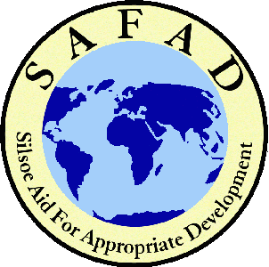 | I would like to become an associate member: £10 (students £5)
 | I would like to renew my associate membership: £10 (students £5)
 | I am already a member and I would like to make a donation:
 | I enclose a donation of £ (cheques made payable to SAFAD).
I am already a member and I would like to make a regular donation by direct debit. I would like SAFAD to send me the relevant forms.

Name:
 | Address:
 | Telephone: | Email:
I declare that I am a tax payer and would like any donation I make on or after 6th April 2003 to SAFAD to be considered as gift aid.

Signed: ……………………………………………………. Date:………………………………………………..

SAFAD, Cranfield University, Silsoe, Beds. MK45 4DT - SAFAD@Cranfield.ac.uk - http://www.silsoe.cranfield.ac.uk/safad
The recruitment process for this year’s batch of volunteers has come to a close and we have seen a record number of applicants. As our applicants have been of such high calibre we are hoping to send more volunteers than ever before, so current fundraising efforts are crucial! We have 16 excellent volunteers who will be placed with our existing projects in Guatemala, Cameroon and Malawi and with our new project in Ethiopia. The applicants came from a range of course disciplines:

Water Management / Community Water Supply, Natural Resource Management, Environmental Diagnostics and Geographical Information Systems. With this combination of people, projects and skills we are certain to fulfil SAFAD’s dual aims:
(i) To relieve poverty in any part of the world by promoting appropriate development
(ii) To advance the education of the students of Cranfield University by the provision of work overseas

Vote of thanks – to the Committee

Congratulations go to our excellent committee who worked extraordinarily hard and had huge success in fund-raising and sending a record number of volunteers this year. All have fulfilled their responsibility in an extremely professional manner; we should all be very proud for making it ALL happen (PR).

Fundraising Note

We are currently undertaking a special fundraising push to ensure that all 16 selected and appropriately placed volunteers will be able to commence work this September. Our target for this is an extra £5,000 (that’s two volunteers’ worth) so we would welcome your additional support at this time.

Communications Assistance

We would be grateful if our members and donors could provide us with their email addresses to assist with our communications and cut mailing costs. So please send us a brief email to safad@cranfield.ac.uk to confirm.

Thanks.

