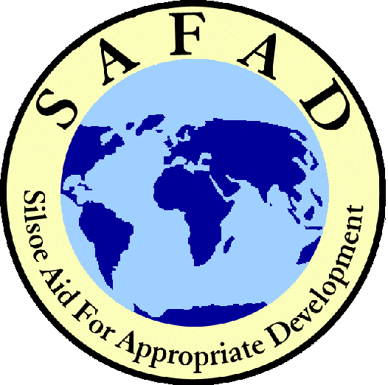
SAMSON

2002

The twice yearly newsletter of SAFAD  E-mail: safad@cranfield.ac.uk  Website: http://www/silsoe.cranfield.ac.uk/safad | Page 1:  Page 2, 3:  Page 4: | Message from the SAFAD Committee  Updates from our current projects  Forthcoming Events, Training; How to Donate

Welcome to the Winter 2002 edition of Samson. The 33-year old SAFAD baton has passed to a new Committee and we are honoured to be able to put our efforts into continuing the work of this wonderful organisation. We thrive as a student run charity dedicated to sending volunteers to places where the world’s poorest people need the skills that they learn here at Silsoe. We currently have twelve volunteers in Africa and Latin America – you can read about their work in the centre pages of this edition.
As the need of the world for Silsoe-trained graduates multiplies, so does the role of SAFAD in helping to equip more volunteers to work where these needs are greatest. So, we are looking at how best to continue our current project involvement and are actively seeking new project opportunities in Africa and Asia. This quest requires additional efforts and it is partly because of this that we are working to increase further campus-wide involvement in our activities. All offers of assistance will be gratefully received!
Soon we shall be starting our selection process for the next group of volunteers to head into the real world in next autumn. Ideally, we would like to despatch an even larger number next year than this, so long as we can raise the necessary funds and manage the process efficiently. The signs are good – we aim to raise some £37,500 this year to send 16 graduates on their way. But we need your help, as a donor, a worker, or message-spreader…
Lastly, all here at SAFAD wish all our readers a very happy Christmas and a joyous and peaceful New Year.
Peter Ryan,
President

We regret to announce the news of the death of Derek Sutton, an enthusiastic and hard working member of our Advisory Committee – our deep sympathies go to his family. In his honour, we will be holding the inaugural Derek Sutton Memorial Lecture on 23rd January 2003 and are thrilled to be able to welcome Ravi Narayanan, Director of WaterAid, as our speaker. Please be sure to book early as spaces will be filled quickly. Please see our website for confirmation of details.

Thank you to the following people and organisations for their kind donations:-
Alfred Haines Charitable Trust, B.Astey, C.Cairns, D.K.Davies, J.E.Elsworth, G.Lovelace, Luton Rotary Club, The Norben Charity, Ove Arup Partnership Charitable Trust, Purley Overseas Trust, Roughley Charitable Trust, St. Marks Overseas Aid Trust, R.Smart, G.Spoor, J.A.Shaw, S.Turner.

SAFAD’s partnership with COMENSA (Comida y Enseñanza para la Salud, Food and Training for Health) is in its fourteenth year, during which potable water and sanitation systems have been provided to the town of Nebaj in Central Guatemala. The job is far from over, with thousands of people still lacking any reliable source of clean water and sanitation. Thankfully, the invaluable partnership still flourishes and has kept its focus on its mission.

Last Year: 2001-02 was a busy year. February and March involved health and hygiene surveys as well as topographical surveys in two villages. Volunteers wrote funding proposals for the construction of water systems in specific villages, including Vi Tos’ Tix. Preparation and planning for school hand washing stations projects were undertaken. Health and hygiene surveys continued throughout the villages, where SAFAD worked in the past, to evaluate the impact of water systems.

The Present Volunteers: We have four volunteers working with COMENSA: Sharon Price, Julien Graveleau, Ester Capilla-Paredes and Elizabeth Gray; all graduates of Silsoe. They arrived in October and are installing a gravity-fed water system in a local village. Three villages have been surveyed, for which each volunteer is designing a water supply system.
They have also been testing solar disinfection - the purification effects of sunlight on small bottles of water. The initial results obtained through this innovative low cost method have been successful.

2002-03: The installation of the gravity water system will continue alongside the design of further water projects. These will involve the continuation of the ‘lavamanos’ (hand washing) project amongst municipal schools in the region.
The volunteers, together with the local health promoter, will introduce/promote this system in the nearby villages and then monitor its progress while they build the water system over the following months.
This is an example of the value of such projects to SAFAD volunteers: they are at the forefront of community water supply projects, learning new ways of addressing real problems in very real situations and assessing their effectiveness.
David Bonnardeaux

We have two volunteers on the Agroforestry project in Guatemala, Laura Arnalte-Mur and Ioannis Manikas, working in conjunction with our local partner ‘AIRES’ amongst rural communities around Chimaltenango
Their work is mainly directed in three areas: One is supporting the tecnicos (AIRES development workers). This involves field work consisting of introducing the programs AIRES is working on, such as advising farmers in the process of running tree nurseries, land resource planning and introduction of agroecology techniques.
Second, AIRES requested work on the production of a database of the agroforestry systems it has set up since 1994. This comprises field surveys, including interviews with farmers and field description; processing data and producing a final report, which will be used by AIRES to review its work in the past and focus that in the future.
The third part of their job followed a proposal made by Laura and Ioannis themselves to AIRES to produce a manual of agroecology. This is designed as a tool to be used by AIRES in its program of organic farming and is to focus on the:
1. Potential for conversion of crops that are currently cultivated in the communities to organic ones.
2. Potential for introducing other beneficial cultivation practices.
3. Commercialisation of their organic products and certification through institutions such as Fair Trade.
Both Laura and Ioannis are getting to grips with the environment they are working in and enjoying their time there. They have a lot of work to do but say that because it is so rewarding they are well motivated to accomplish what they have set out to achieve in their time there.

Matt Cracknell

The Malawi Macadamia nut project – called EDETA - has been running since 2000. Its purpose is to increase macadamia production to commercial levels, help to establish a community based farmers' organisation, whilst contributing to soil conservation
With the SAFAD volunteers, Justin Ward and Nick Evans, EDETA is working with 8 nurseries that are well developed such that the farmers are planting new trees every year. However, macadamia trees to do not bear fruit for up to 7 years, so they are building up other areas too.
One of these is the development of a community based farmers association: SUMESMA, whose members are becoming self-sufficient through the development of a micro-credit system. The aim when the project ends in 2003 is that SUMESMA will continue the development process of the nurseries and the creation of new community projects.
The development of the micro–credit system has enabled farmers to achieve independence as they can fund new income generating activities such as guinea fowl and

chicken breeding and beekeeping while the macadamia trees are maturing: Justin and Nick are concentrating on training farmers in new income generating activities requested by them and promoting soil conservation and reforestation.
They will assist in the interplanting tefrosia trees with maize; this yields multiple benefits including soil conservation and nitrogen fixing, as the cuttings can be used as mulching to improve the soil. The plant also has medical properties. The volunteers are helping to educate the farmers on the need for this type of mixed agroforestry work.
They are also working toward an integrated pest strategy for hybrid maize and macadamia nuts, they are looking for funding for a treadle pump and to buy seeds so that the farmers can grow vegetables in the hot season.
Some encouraging news for the project is that the Minister for Agriculture has announced that it will be giving SUMESMA an additional 8-9 million Kuwatra to expand the project into another region. Our volunteers will help to set-up this expansion programme.
Julia Binns

In October 2002, the four SAFAD volunteers (Jay Benthley, Clair Hatfield, Melanie Carraso and David Bell) commenced work with the local partner SOWEDA on a water supply project near Bangem in the savannah area near the Bakosi Mountains, thereby continuing the SAFAD presence there which started back in 1989.
Over this period, 32 volunteers have installed water supply systems in 12 villages, and have included additional work such as surveying and irrigation development.
The project is 6-8 months duration as the rainy season prevents construction work for the rest of the year. Technical design and management is provided by the SAFAD volunteers, while construction, operation and maintenance is primarily provided by the local population.
The overall goal is to provide safe water and improved sanitation using appropriate technology and community participation giving:
- Improvements in community daily life;
- Massive reduction in time women and children spend collecting water;
- Safe spring water gravity feed supply;
- Improvements in sanitation provision with consequent health benefits.
Recent work includes the design and installation of a new water supply in the village of Muanyet with community participation. This gravity water supply carries water 1 km from a spring up the hillside through a pipe and tank system to taps near the houses in the village.
“These and all our projects have done huge amounts to alleviate hardship and improve health in the villages” the volunteers report, “the skills and confidence of the villagers have increased immensely too”
Youssef El Haoussine

Being a successful volunteer is not all about education. Although the skills and expertise our volunteers possess through their study at Silsoe are of the highest value, to be a real benefit to the project we have to ensure that they can lend a hand to anything. SAFAD organises a two-week ‘training and preparation’ session in the month prior to departure, when we train our volunteers in practical skills ranging from first aid and cement mixing to motorbike maintenance! This constantly updated course aims to give our volunteers all the skills and groundwork they need when living and working overseas including in the community awareness that they will need. The course is hosted here at Silsoe, and is given by staff, previous volunteers, St. John Ambulance... We also provide in-country language lessons. We aim to give our volunteers the best start possible!

SAFAD continues to raise money by organising events on and around Silsoe campus. Sunday film nights are on-going, we have managed to entice even more people with home-made pop corn! We have had an international music chilli night and danced the night away at the Silsoe school disco!

Next year will be even more jam packed with fun, events and fundraising: Ravi Narayanan of WaterAid will be giving our inaugural annual lecture (see front page). The SAFAD Annual Seminar will take place in late spring – the date will be announced shortly. This will be an opportunity for you to find out about the fantastic work our volunteers are doing and to learn more about what is going on at SAFAD.

We also hope to stage Romeo and Juliet later in the Spring: Wherefore, methinks ye ask? To raise some money, forsooth says reader Mr. W. Shakespeare of Stratford upon Avon.

A Burns Night Supper to raise funds for SAFAD is to be held on Friday 24th January in the main Dining Room. Highlights (?) will include the SAFAD President addressing the haggis in traditional style, the skirl of pipes and drums, Scottish dancing and much carousing - a fine night is in store! Details to follow soon.

Join SAFAD or renew your membership and receive our newsletter with project updates.

Your contributions are essential to our work. Registered charity No. 289621
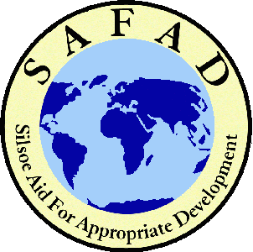 | I would like to become an associate member: £10 (students £5)
 | I would like to renew my associate membership: £10 (students £5)
 | I am already a member and I would like to make a donation:
 | I enclose a donation of £ (cheques made payable to SAFAD).
I am already a member and I would like to make a regular donation by direct debit. I would like SAFAD to send me the relevant forms.

Name:
 | Address:
 | Telephone: | Email:
I declare that I am a tax payer and would like any donation I make on or after 6th April 2002 to SAFAD to be considered as gift aid.

Signed: ……………………………………………………. Date:………………………………………………..

SAFAD, Cranfield University, Silsoe, Beds. MK45 4DT - SAFAD@Cranfield.ac.uk - http://www.silsoe.cranfield.ac.uk/safad

[[[

